**PROJECT TITLE: E – AGRICULTURE**

1. **ABSTRACT**

The main objective of this project is building a website which will help Indian farmers to make the effective cultivation by providing information crop and make a path to earn more money from Indian villages by sell their products to different cities online and by registering their crops to get their suitable price for their crops. They can open this site and register with it and sell and buy their products and register their crops online etc.

1. **INTRODUCTION:**

In India agriculture is the main source of employment over 58% of India’s population. E-Agriculture is one of the key part of digital India. It is designed to support the development and exchange of localized information and services to make farming more profitable and sustainable (socially, economically, and environmentally) to deliver good food for all. This helps farmers to increase their profits and can empower rural farmers with good awareness by accessing equitable markets and rural business to offer value added services. It also includes several managements that helps E-Agriculture such as soil, seed, fertilizer, pest, harvest managements to create healthy farming. It is also a mission mode project

By this website the farmer will get all the products for farming directly. So the farmer will not have any loss. The farmer will be given money based on the productivity of crop. So both the government and farmers will be benefited. Crop management is done to balance the price of the crop

1. **OBJECTIVES:**

* + The website “E-Agriculture” is for farmers.
  + This website contains the information about different types of effective farming and irrigation techniques.
  + This website give information on crop management to satisfy the demand of particular crop to reduce crop price.
  + Through this website the government can buy product directly from farmers.

• Through this website the farmers can buy seeds, fertilizers directly

* + The farmers can have a deal with government for certain cost.
  + So farmer can have a lot of profits.

1. **Hardware and Software specifications:**

Software Requirements:

Operating System : Windows 10,

Technology : Net Beans

Database : MySQL

Hardware Requirements:

Intel Pentium

Processor speed-1.2 GHz or above

1 GB RAM minimum

1024 GB Hard Disk Space

1. **Existing system:**

There is no computerized system for the farmer to register for the crops, to buy seeds, fertilizers, to sell their product. Currently, the farmer grow the crops what they wish, by which all the farmers goes to same crop and grow the same crops will leads to demand for other crops and increase in crop prices. And farmers goes to nearest market handover his product to a particular agent, agent ask the farmer to visit the market after a specific time to collect the cash earned out of the sold product. Agent sells the product to another agent or a dealer at the cost of that market. Every Agent tries to cuts his commission out of that. There is no way for farmer to know about the deal and the exact amount at which their product was sold. There is no transparency. No facility is present for the farmers to know the product rates at different markets where they can sell their products for achieving high profits. Many times, farmers are not even aware of the schemes and compensation provided by government. In spite of all the opportunities banging the doors the farmers are not able to benefit out of those. Current system does not provide the way of e-learning for farmer that will provide the knowledge of new techniques in farming. So he doesn’t get the maximum profit through the current system.

1. **Proposed System:**

We are going to develop e-farming application that fulfil all needs of the farmer and give the solution. We have multiple sections like login for farmer/people to use it on their own way. As per requirement of our application who will using the application via mobile phone i.e. an android phone .Next section there is web panel from this the government agency .In this application we also included registration of crop which leads to balance of crops another one feature like buying the products for crops like seed, fertilizers. Selling the crop which help to farmer to sell without agent and get fruitful result. Our main goal is to help the farmer which is in trouble and give him to user friendly application

1. **Modules Description:**

**Login:**

This helps the farmer to login by which they can know about soil information Crops suitable for different region and government schemes and register the crops which they want to produce.

**New Register:**

If farmer want to login he has to first register by clicking new register and Filling the details

**Home:**

Once the farmer has logged in he can register the crops in their region, buy products,

Sell products, Know crop information, soil information, schemes given by the government , update details, available in home

**Crop Management:**

It has all information about crop suitable for different region, soil information, and all crop Information, scheme of the government

**Crop Registration:**

It helps the farmer to register for the crops what they want to produce in their region. Which leads to balancing of crops and certainty in price of crops

**Buy Products (seeds, fertilizers):**

It helps the farmer to buy fertilizers and seeds from the government without and agents between

**Update details:**

It helps the farmer to update to their details which they have filled in new registration

**8.SCREENSHOTS**

1. **Login:**

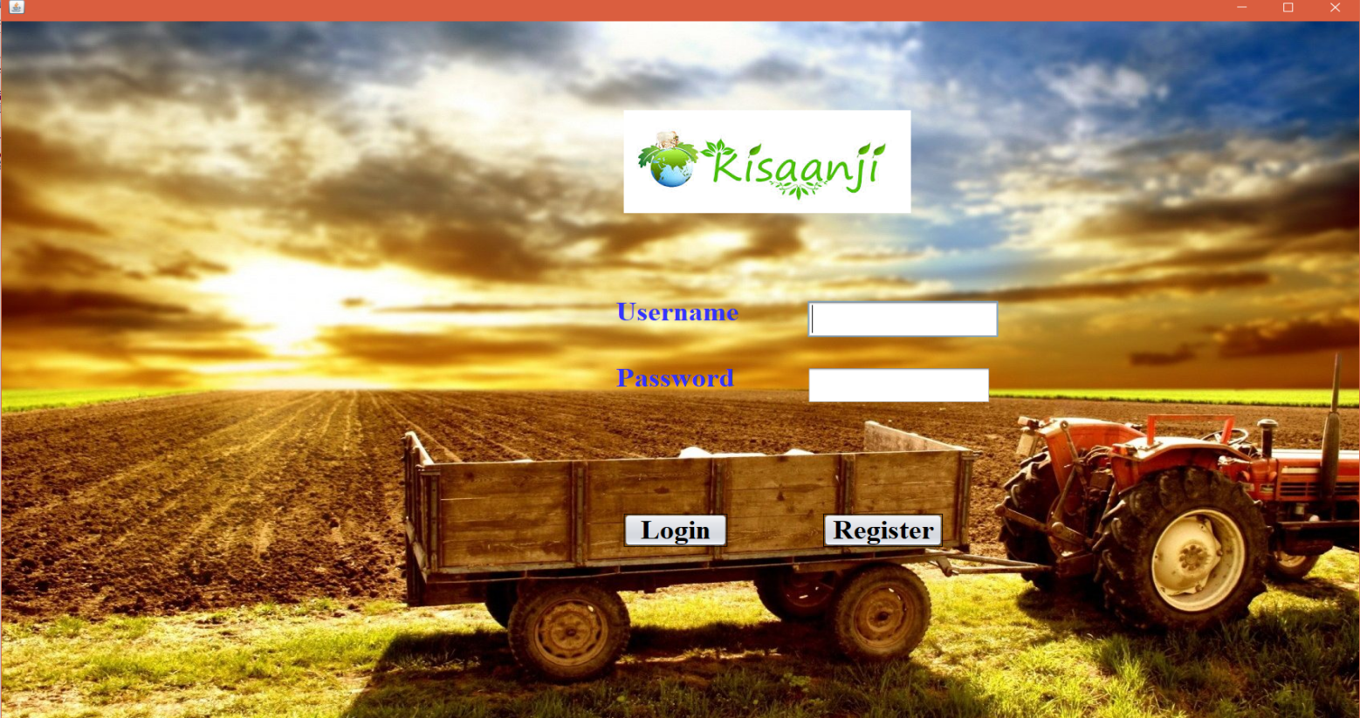

1. **New register:**

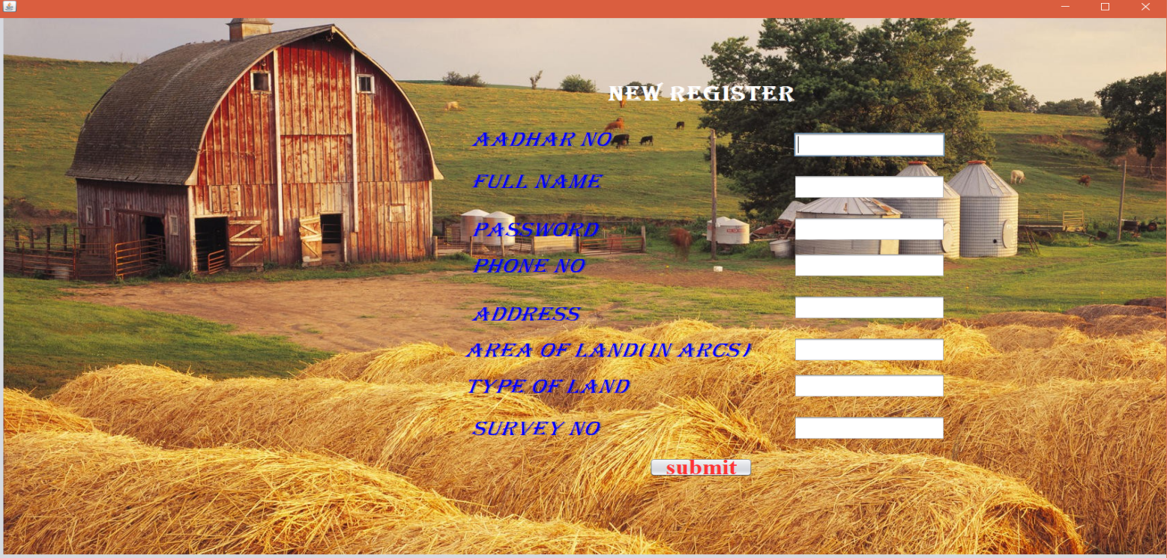

1. **Home:**

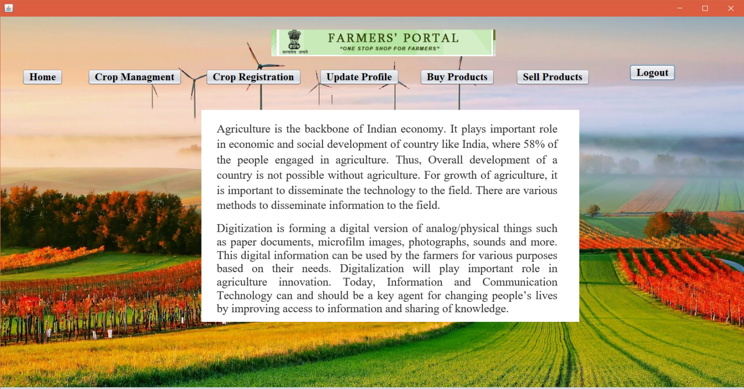

**4.Crop Management:**

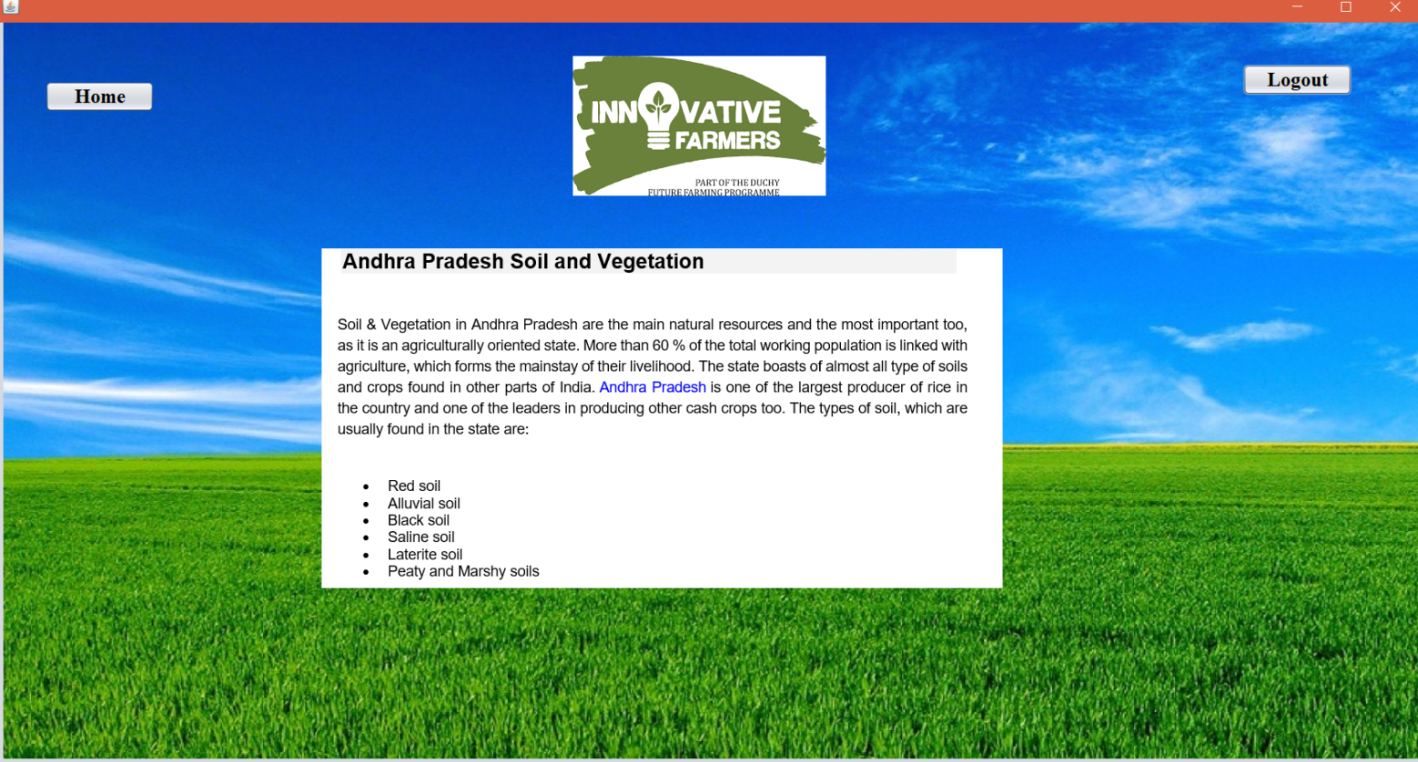

1. **Crop Registration:**

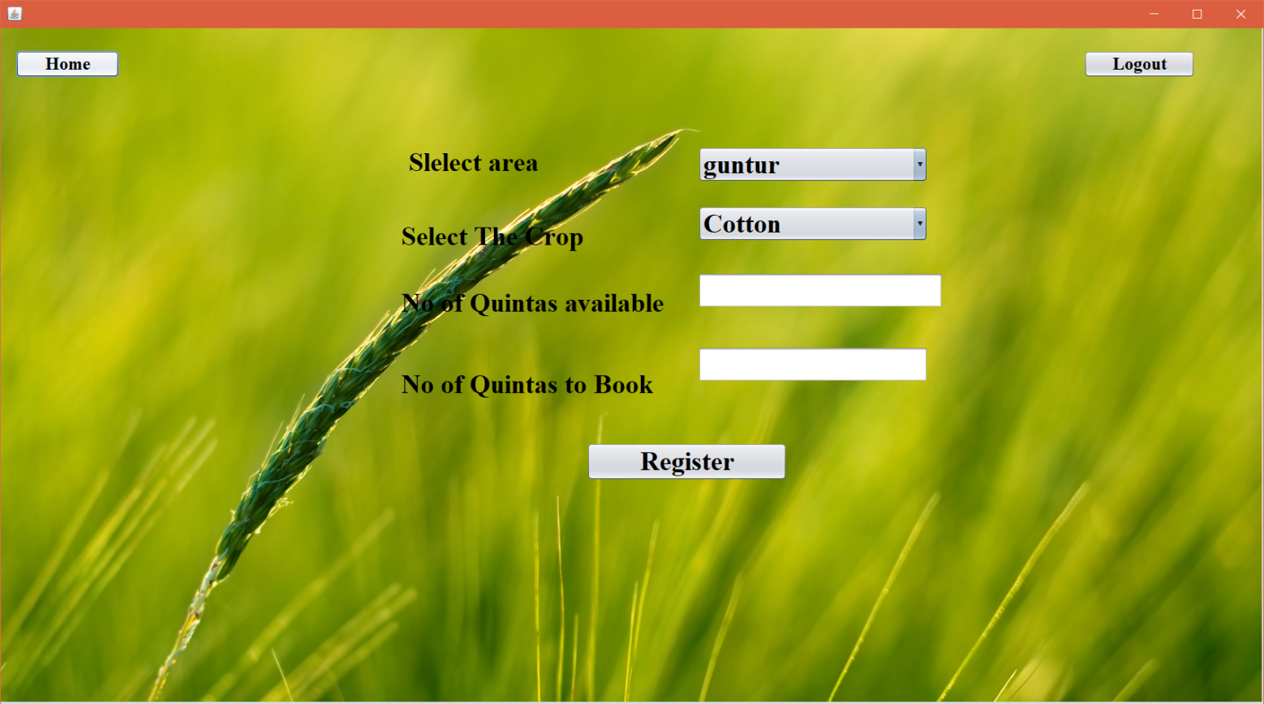

**6.Update Profile:**

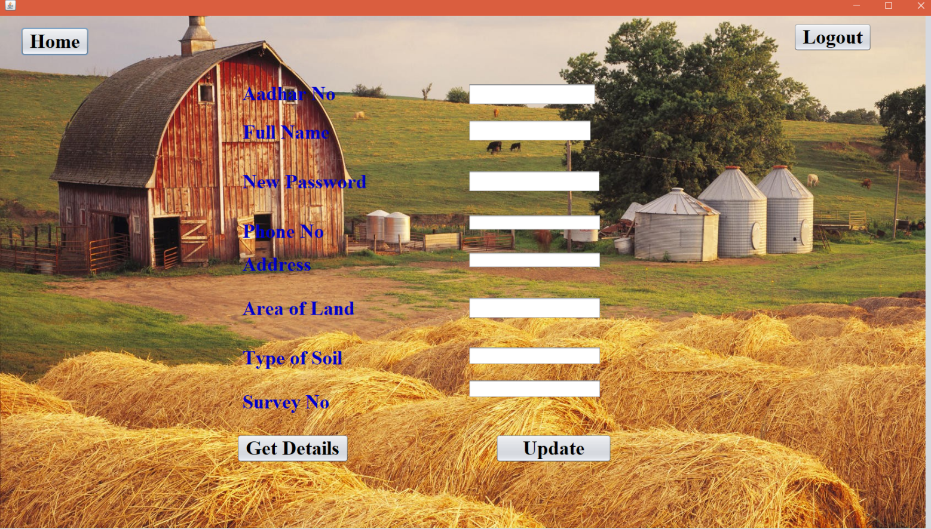

**7.Buy products:**

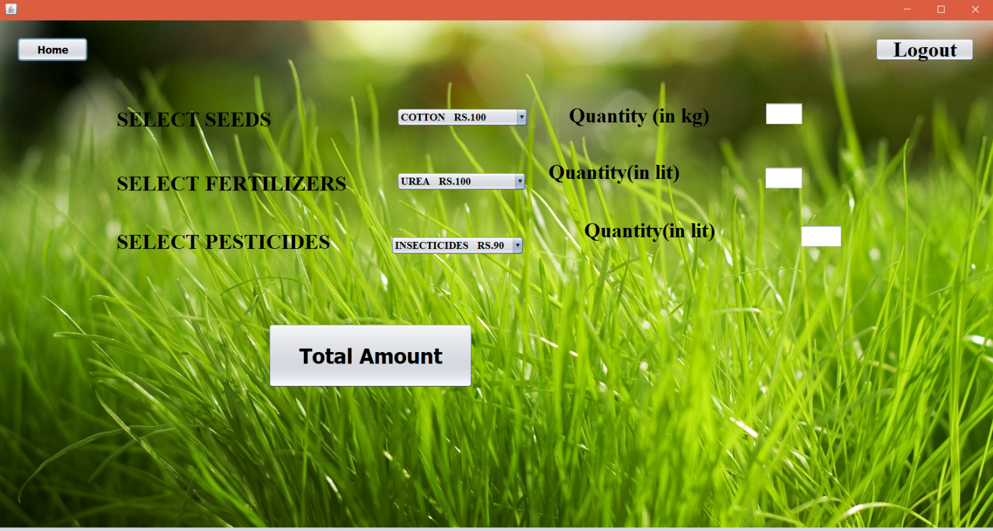

**8.Sell Products:**

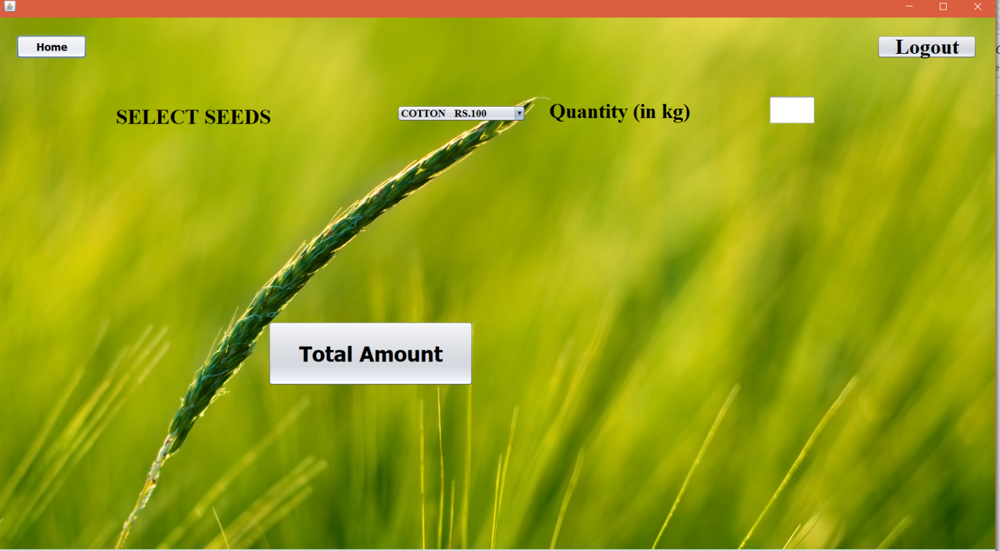

**9.Logout:**

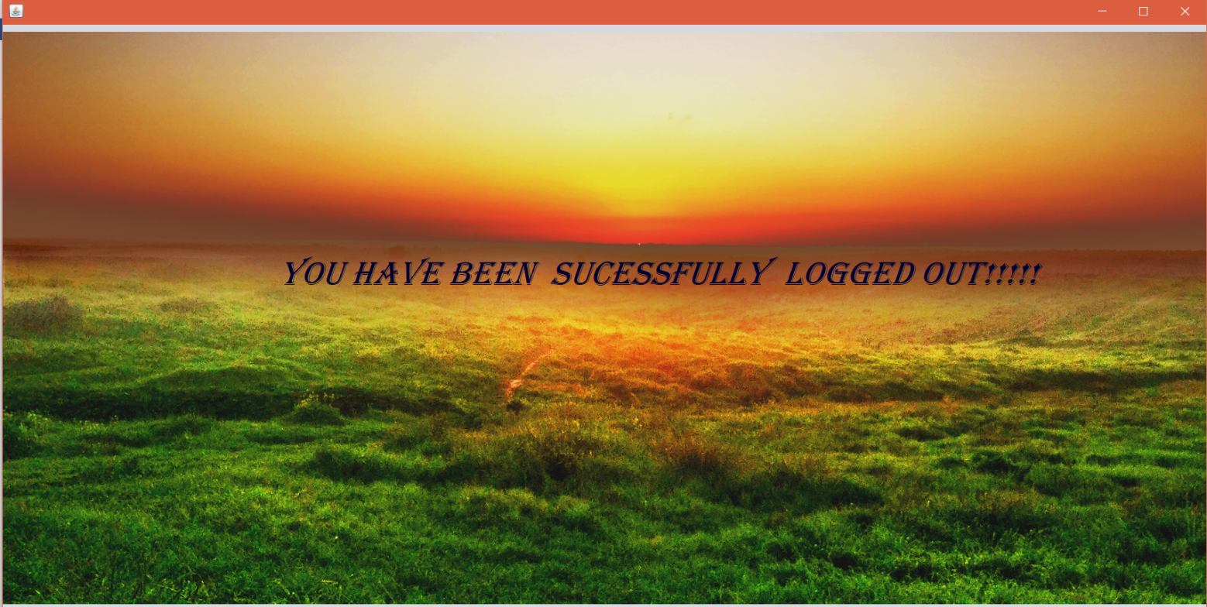

**9.Conclusion:**

This project will be helpful for farmers to know more about crops that will act as unique interface of schemes and compensation. Through this they will be always in touch of new technique and trends of farming. But to some extent, new user may feel some kind of stress about its use. Overall this system is faster, secure and comfortable.

An interface e-farming to accessing the agricultural information from the global repository of internet and the local repository has been proposed in this paper. This also helps farmers for efficient use of mobiles and internet.